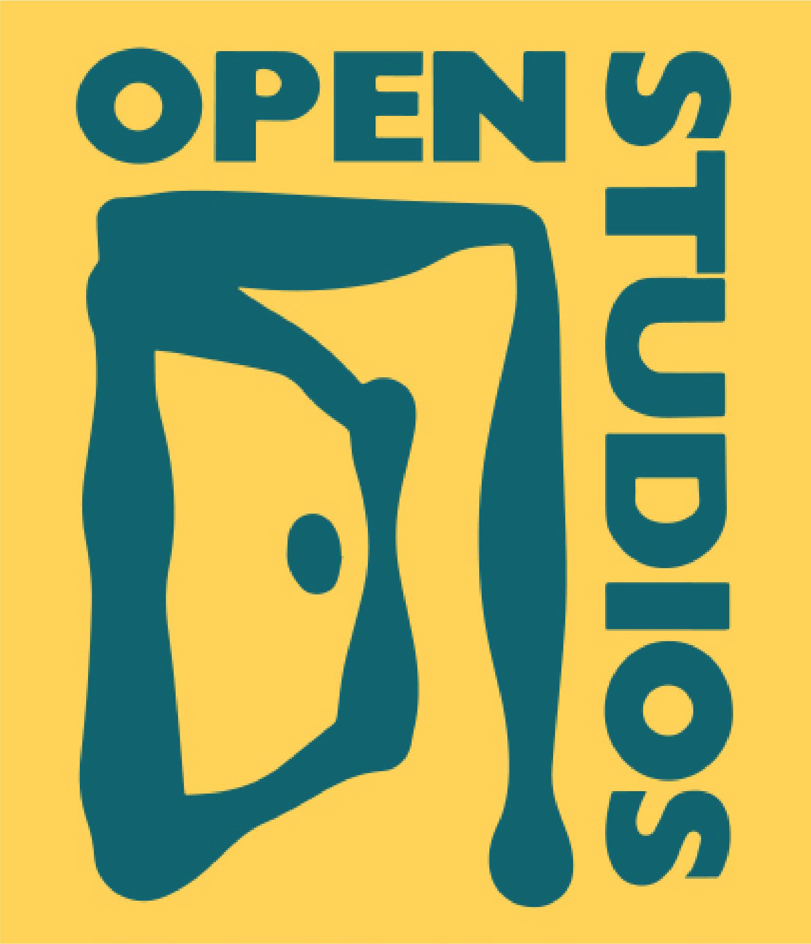
OPEN STUDIOS
For Immediate Release

Contact: Mary Horrocks, Executive Director
mary@openstudios.org | cell: 303-748-9132

Open Studios Announces the 26th Annual Tour of Artists’ Studios

Boulder, CO, Sept, 2020 - Open Studios of Boulder, Colorado celebrates the 26th anniversary of the Open Studios Tour. This year’s Tour of artist studios promises to be among the best ever with nearly 140 juried artists participating. The Tour is free of charge, open to the public the first three weekends of October, and is appropriate for all ages.

From its beginning in 1995, Open Studios has set rigorous standards for the Tour and its participating artists. Each year, the artists who apply are juried by seasoned professionals in the field of visual art. During the Tour, artists display work that they offer for sale, are available to talk with patrons, and also provide an educational display or demonstration to help visitors understand their practice and inspiration. Last year over 6,800 patrons each visited an average of six studios on the Tour, for an estimated total of 41,000 studio visits. The Tour takes place Saturday and Sunday, noon to 5:00 pm – October 3, 4, 10, 11, 17 and 18.

Patrons can utilize the Tour Catalog/Map – available both on-line and in hard copy – to pick which artists to visit. The listings show an image of each artist’s work along with a studio number and location that is cross-referenced to the included map. Additionally, each studio uses Open Studio street signs to guide visitors to their location. Hundreds of these signs can be spotted in almost every neighborhood, so passer-bys can spontaneously drop-in on studios.

The Tour kicks off Friday, Oct. 3rd, 6 - 8:30 pm with the “Preview Exhibit,” a gallery show featuring one piece of art by each artist, and hosted this year at The Museum of Boulder, 2205 Broadway, in Boulder. The Preview Exhibit will be open daily from 10 am - 5 pm, Oct 4 - 18, and is also a great way to create a self-guided studio tour. All artworks on display are for sale.

Open Studios has been recognized for excellence by our peers in the local arts community. We received last year’s prestigious Dairy Center Honors award for visual art at a presentation on September 6, 2019 at Boulder’s Dairy Arts Center.

A registered 501(c )(3) non-profit organization, Open Studios also provides five additional programs in year round support of the visual arts and artists in the Boulder community: POP! Gallery, in collaboration with Downtown Boulder, opening temporary retail gallery spaces in the summer and holiday months; the Mobile Art Lab, helping build community in neighborhoods across Boulder; EdLinks, providing supplemental arts education in public schools; the Community Public Art Program, providing quality public art for Boulder; and the Boulder Plein Air Festival, hosting top artists from around the country.

For more information: www.OpenStudios.org, 303-444-1862, info@OpenStudios.org

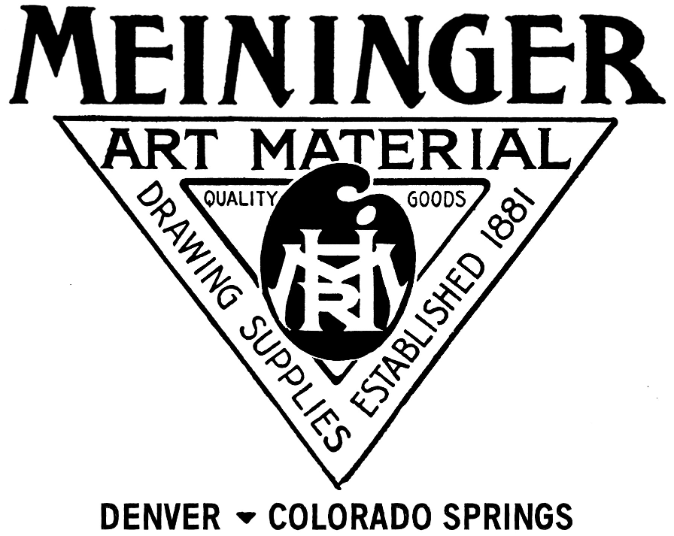
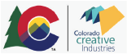
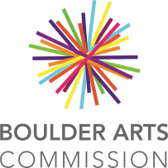
Many thanks to our major sponsors:
